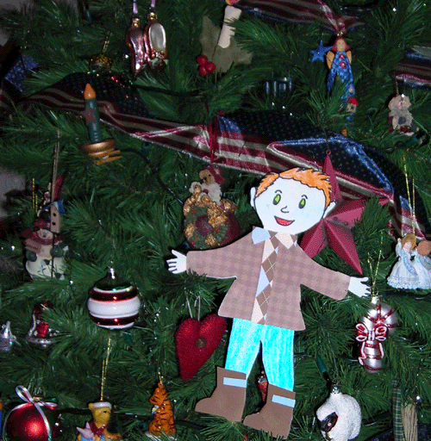

December 7, 2006:
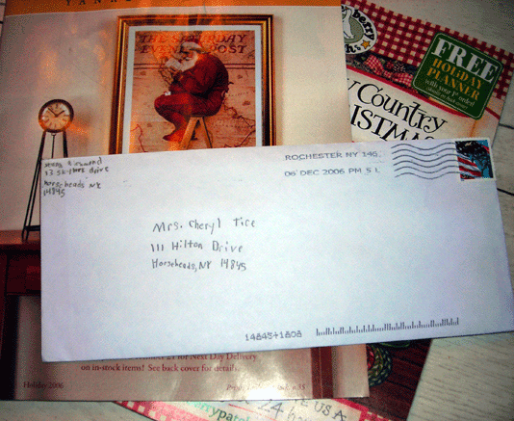
Phew! I’m glad I finally made it to my destination. Here I am sitting on the table in my envelope waiting to be opened.

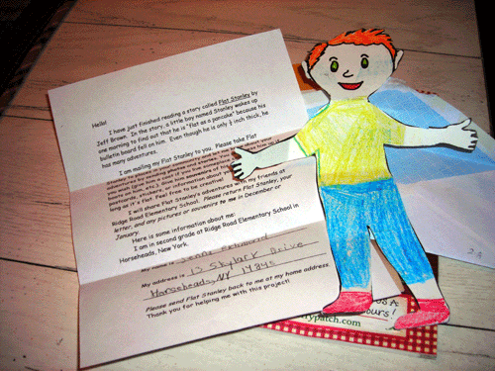
When Cheryl got home from work, she saw that her friend Jenna had sent her a letter. She opened it up and out I popped! It was a relief to unfold myself.

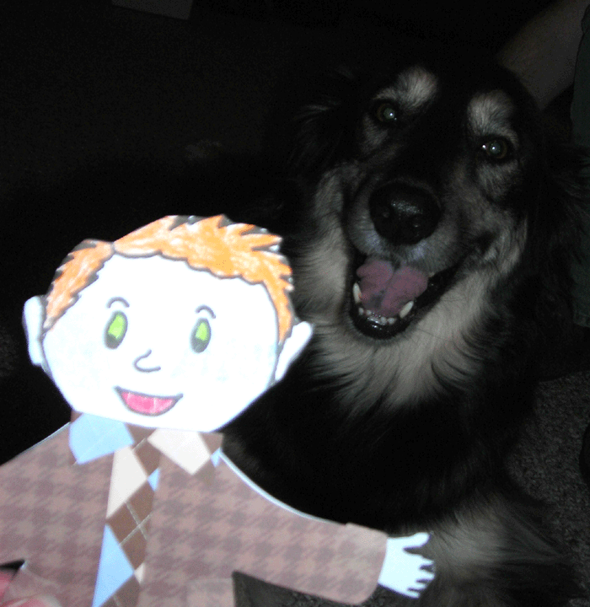
Then Dan and Cheryl introduced me to their dog Charlie. We became friends very quickly…

I went for a walk with them. It was very chilly, so I had to bundle up in my winter coat and boots. Brrrr! I’m glad it was a short walk!
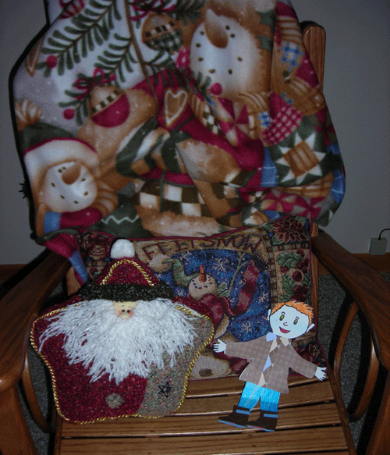

I’m getting up early tomorrow morning. I promised to help Cheryl at work. They are having a Christmas party next week and I’m invited!

Good night!

December 8, 2006:

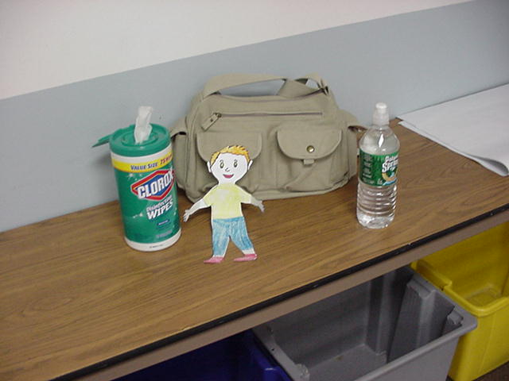
I think I did an excellent job helping Cheryl decorate for the party at work next week. First I helped clean the room.

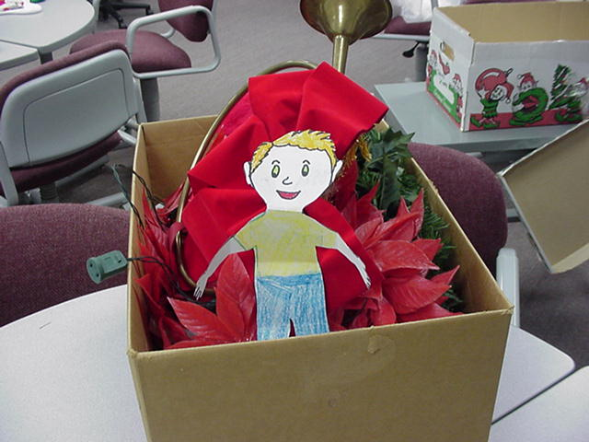
Next we found the decorations and picked what we wanted to use.

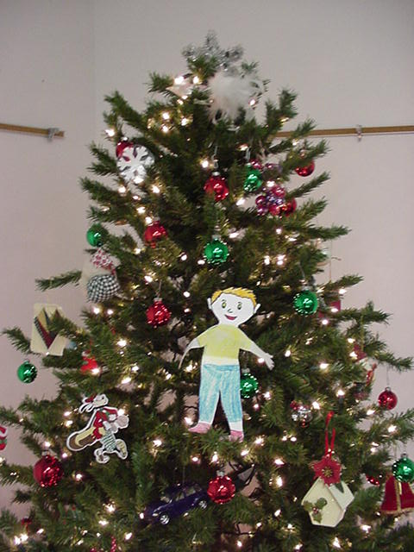

Then we set up the Christmas tree and put up the decorations. When we were finally done, it looked very nice!

December 9 - 10, 2006:
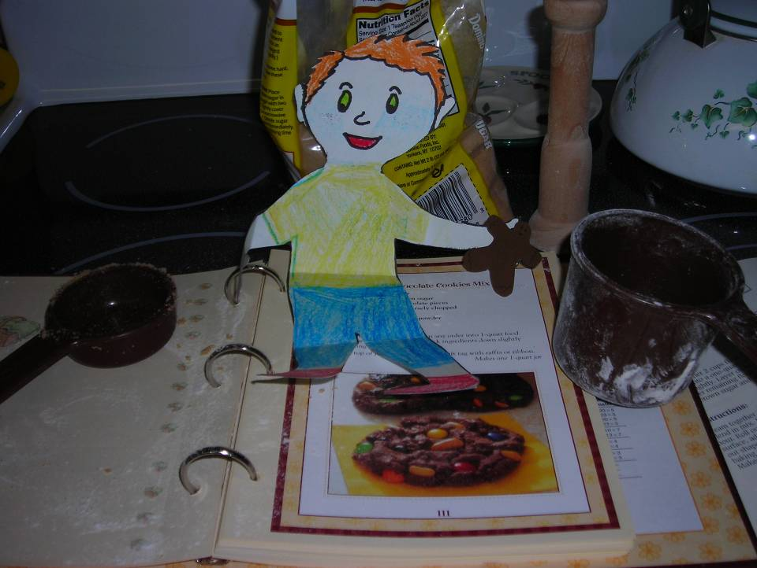
Over the weekend Cheryl and I went shopping for Christmas presents and made gingerbread cookies.

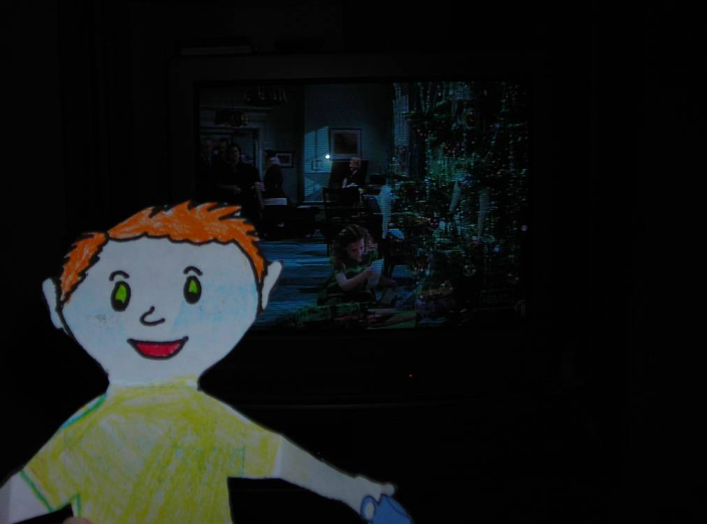
We also watched Christmas movies on TV while we drank hot chocolate.

December 11, 2006:
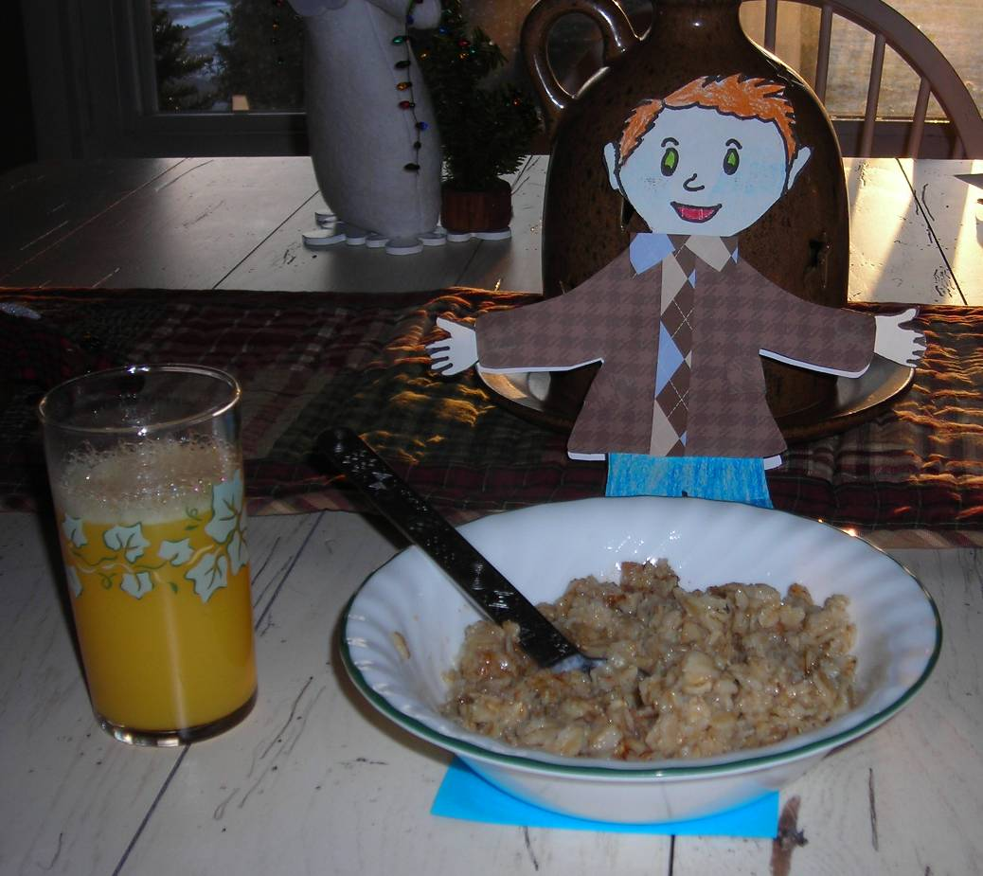
Dan made us oatmeal for breakfast today.

After school Cheryl and I taught a technology class to teachers. We used digital cameras to take pictures and movies to use in PowerPoint.

December 12, 2006:

We watched Jeopardy after work today. I answered more questions than Cheryl, but Dan answered the most questions.

Before we went to sleep, we put all of the stuff we need for the party on the dining room table. Cheryl wrote a note for us to remember the cookies.

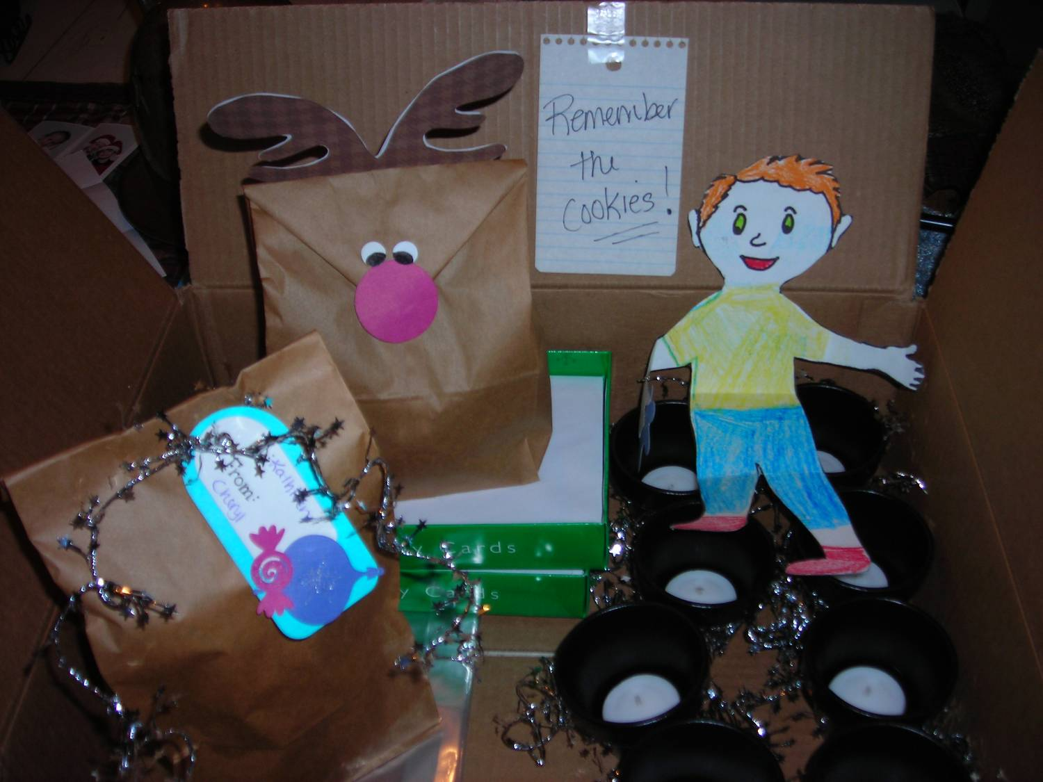

I am very excited about the party tomorrow!

December 13, 2006

It was fun helping Cheryl finish decorating for the party. It started at noon. Everyone brought something to eat and everything tasted so good!

I can’t believe it is time to go back and tell Jenna about all of the fun I’ve had during the last week.

Goodbye for now!



