Name:
Date:
6th/7th Grade Review Packet
Directions: Complete the review packet and bring it back for a bonus. If you are unsure what to do, you can go to kanacademy.org or YouTube.com to fresh your memory.
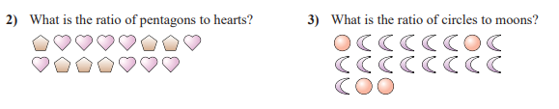

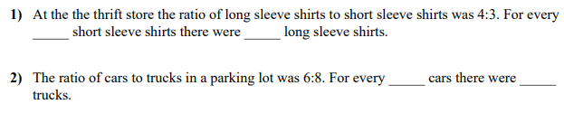

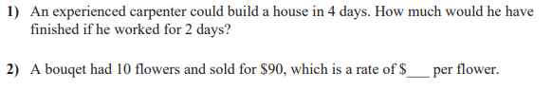

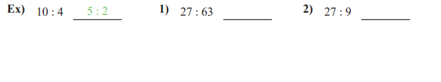
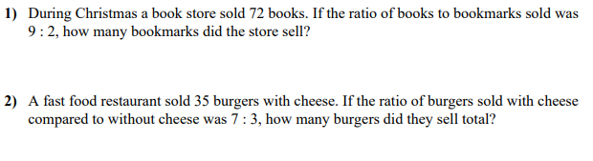
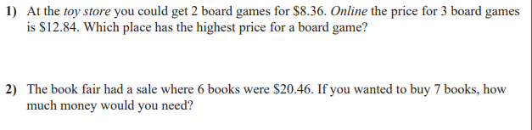

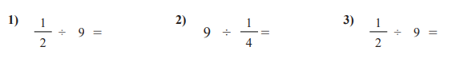

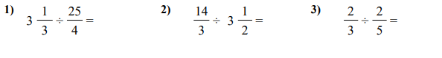

Use >, <, or =
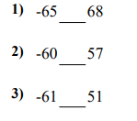

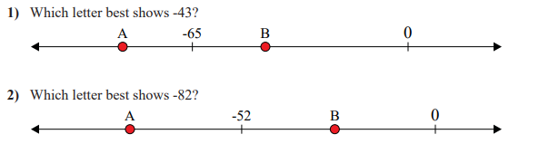

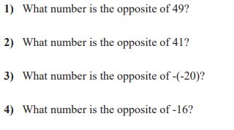

Use >, <, or =
