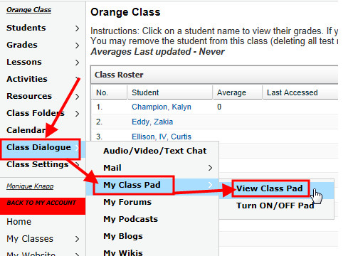

Follow this path to the list of STD/STI’s that you and your partner will be able to sign up for

