Lab 4: Volcanoes
Section | Points
Concepts/Objective 5
Variables/Hypothesis 5
Observations/Data 5
Procedure 5
Questions/Conclusion 10
Total
Regents Minutes
Project Director
Safety Director
Materials Manager
Technical Manager
LabQuest #
Laptop #

Introduction/Pre-Lab
A volcano is a rupture in the crust of a planetary-mass object, such as Earth, that allows hot lava, volcanic ash, and gases to escape from a magma chamber below the surface.
The most common perception of a volcano is of a conical mountain, spewing lava and poisonous gases from a crater at its summit; however, this describes just one of the many types of volcano. The features of volcanoes are much more complicated and their structure and behavior depends on a number of factors. Some volcanoes have rugged peaks formed by lava domes rather than a summit crater while others have landscape features such as massive plateaus. Vents that issue volcanic material (including lava and ash) and gases (mainly steam and magmatic gases) can develop anywhere on the landform and may give rise to smaller cones such as Puʻu ʻŌʻō on a flank of Hawaii's Kīlauea. Other types of volcano include cryovolcanoes (or ice volcanoes), particularly on some moons of Jupiter, Saturn, and Neptune; and mud volcanoes, which are formations often not associated with known magmatic activity. Active mud volcanoes tend to involve temperatures much lower than those of igneous volcanoes except when the mud volcano is actually a vent of an igneous volcano.
Shield volcanoes and stratovolcanoes have different shapes and different slopes (look back at Lab 2 to refresh your memory). The ratio of (the height of the volcano ÷ the half-width of the base) is a way to tell whether the volcano is a shield or stratovolcano.
A shield volcano has a ratio value less than 0.18, typically about 0.10. This ratio gives the shield volcano a gentle slope, less than 10° and usually about 5°. A stratovolcano has a higher ratio, greater than 0.18, even as much as 0.25. This gives the stratovolcano a steeper slope, greater than 10° and usually about 15°.
A caldera is a large cauldron-like depression that forms following the evacuation of a magma chamber/reservoir. When large volumes of magma are erupted over a short time period, structural support for the crust above the magma chamber is lost. The ground surface then collapses downward into the partially emptied magma chamber, leaving a massive depression at the surface (from one to dozens of kilometers in diameter).
Cinder cones result from eruptions of mostly small pieces of scoria and pyroclastics (both resemble cinders, hence the name of this volcano type) that build up around the vent. These can be relatively short-lived eruptions that produce a cone-shaped hill perhaps 30 to 400 meters high. Most cinder cones erupt only once. Cinder cones may form as flank vents on larger volcanoes, or occur on their own. Classifying Volcanoes
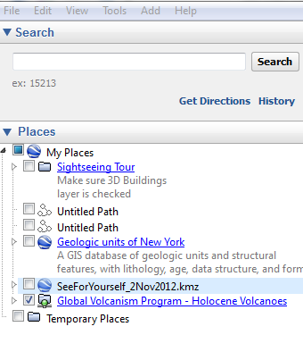
- Open Google Earth on your computer.
- Change units to meters, kilometers by clicking on the “tools” menus, selecting “Options” and selecting “meters, kilometers”
- Under the Places tab on the left hand of the screen, check the box labeled Global Volcanism Program–Holocene Volcanoes
- Use Google Earth to visit the volcanoes listed in Table 1 beginning with Mount Etna and determine the measurements necessary to classify each volcano. Use the search window to help you find the 1st volcano that is listed in Table 1.
- Be sure to zoom in and rotate the screen. Click on anything you like to learn about the volcano.
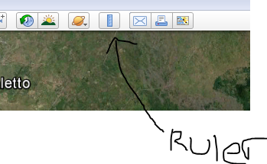
- Acquire the necessary information using the elevation at the bottom of the screen to determine summit and base elevations and the ruler tool to measure base width.
- Complete Table 1 in the data portion of the lab to identify the type of volcano you have.
- If your volcano is not a stratovolcano or a shield volcano, identify the type and explain your reasoning based on its characteristics.
- Repeat steps 4 through 8 for each volcano in Table 1.
- Plot the location of your volcanos on the map found on the next page.

Volcano Name | Elevation of Summit | Elevation of Base | Width of Base | Volcano Height ÷ Half of width of base | Volcano Type | Location  (ocean, edge of continent, middle of continent)
Mount Etna
Volcan de Fuego
Mt. St. Helens
Piton de la Fournaise
Mauna Loa
Negro, Cerro
Nazko
Crater Lake
Cleft Segment
Choose your own

- In what types of locations do stratovolcanoes tend to occur? Shield volcanoes?

- What type of volcano is associated with convergent boundaries?

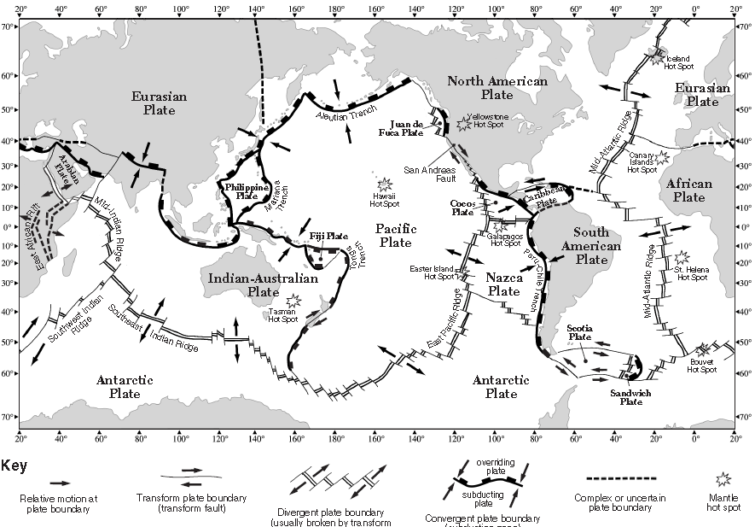
SCIENCE CONCEPTS (5 points)
____________________________________________________________________________
____________________________________________________________________________
____________________________________________________________________________
____________________________________________________________________________
____________________________________________________________________________

Investigative question
How does the viscosity of a magma affect the its rate of flow?
OBJECTIVE
____________________________________________________________________________
____________________________________________________________________________
VARIABLES (5 points)
Manipulated Variable (Independent):______________________________________________
Responding (Dependent):________________________________________________________
HYPOTHESIS (If…then…because)
____________________________________________________________________________
____________________________________________________________________________
____________________________________________________________________________
____________________________________________________________________________

Materials
- Computer
- Ramp
- Blocks of wood to elevate ramp
- 3 liquids with varying viscosities
- 3 test tubes
- Test tube holder
- Black Marker
- Beaker
- Timer
Procedure
Magma Properties
- Gently swirl and observe the liquids in the three test tubes. Which seems to be the thickest (most viscous)? Which seems to be the least thick (least viscous)? On your “Data Sheet” handout, predict which liquid is the most viscous, which is the least, and which is in between.
- Assign a value of 1 (least viscous) to 3 (most viscous) to the three liquids. Record the values.
- Make a ramp by balancing your ramp on the edge of the wooden block.
- Line the surface of your boards with aluminum foil.
- Use your marker create a starting line 5 cm from the top of your ramp.
- Create a finish line 10cm from the starting line with the marker. Record this distance on the “Rate of Flow Results” table on your “Data Sheet” handout.
- Predict how the viscosity of each liquid will affect the speed with which the liquid flows down the ramp. Which liquid will have the fastest speed down the ramp? Which will have the slowest? Record your predictions on your “Data Sheet” handout.
- Pour one plastic teaspoonful of one of the liquids just before the starting line and start timing as soon as the liquid crosses the start line. Stop the timer when the liquid crosses the finish line. Record the results. Clean the ramp and repeat the test two more times, using a new starting line each time. Average your results.
- Calculate the flow rate by dividing the distance of the ramp by the average time it took the liquid to cover that distance. Record the flow rate or speed in your data table.
- Repeat steps 8 and 9 for the other two liquids.
- Display your flow rate results for the three liquids in a bar graph. Label the x-axis “Liquid” and the y-axis “Rate of Flow (cm/sec)”.

DIAGRAM OF THE EXPERIMENT (based on the procedure) (5 points)

OBSERVATIONS/DATA (5 points)

TABLE__:____________________________________________________________
 | Time Trial 1 | Time Trial 2 | Time Trial 3 | Average Time | Distance | Flow Rate
Liquid A
Liquid B
Liquid C

QUESTIONS (10 points)
- Compare the relative viscosities of the liquids to the speeds with which the liquids moved during your ramp tests. Based on your data, how does the viscosity of the liquid influence the rate at which the liquid flows?

- Nyiragongo is said to have lava that flows "like water." Based on your investigation, describe the viscosity of the lava produced by Nyiragongo.

- How might the viscosity of lava from a volcanic eruption affect the outcome of an evacuation?

- Which type of volcano is most likely associated with a high viscosity magma? A low viscosity magma?

- Which liquid do you believe would produce the most violent eruptions, high viscosity or low viscosity? Why?

- Predict: How does temperature of a fluid affect its viscosity? How would you test your prediction?

What relationships did you observe between the variables?
______________________________________________________________________________
______________________________________________________________________________
______________________________________________________________________________
______________________________________________________________________________
______________________________________________________________________________
______________________________________________________________________________
______________________________________________________________________________
What predictions can you make based on your observations?
______________________________________________________________________________
______________________________________________________________________________
______________________________________________________________________________
______________________________________________________________________________
CONCLUSION
I accept or reject my hypothesis (circle one)
What evidence did you use to accept or reject your hypothesis?
______________________________________________________________________________
______________________________________________________________________________
______________________________________________________________________________
______________________________________________________________________________
How can you use this knowledge?
______________________________________________________________________________
______________________________________________________________________________
______________________________________________________________________________
______________________________________________________________________________
Turn in your data table, graph, and answers to the questions above along with your lab report.

