**Lab 5: Magnetism and Seafloor Spreading**

**Introduction**

*Magnetism* is the force of attraction or repulsion between a magnet and something else. Magnets attract materials made of iron, nickel, or cobalt. Can you think of five things to which a magnet may be attracted? Does it matter which end of the magnet is brought near the object

*Like poles repel*

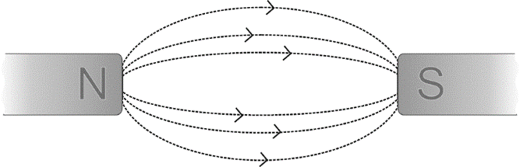All magnets, no matter what their shapes, have two regions called the north and south poles. The north pole of the magnet is the one that points north when the magnet is suspended in the air. When two like poles (i.e. north and north or south and south) are brought near each other, they repel each other. When two unlike poles are brought together they are attracted. The forces of repulsion and attraction are present because of the magnetic field that completely surrounds the magnet. Magnetic field lines extend out from the north pole into the south pole.

*Unlike poles attract*

The field lines are more concentrated near the poles of the magnet so the magnetic field is said to be stronger near the poles. The strength of the magnetic field can be measured using a Magnetic Field Sensor. The greater the number of magnetic field lines that pass through the white dot on the sensor, the stronger the field. When the field lines enter the side of the sensor with the white dot, the magnetic field reading is negative. What do you think would happen if the Magnetic Field Sensor were turned around so that the lines passed from the back of the sensor? You will investigate this in Part I of this experiment. In Part II of this experiment you will investigate the relationship between the orientation of the Magnetic Field Sensor and the strength of the magnetic field.

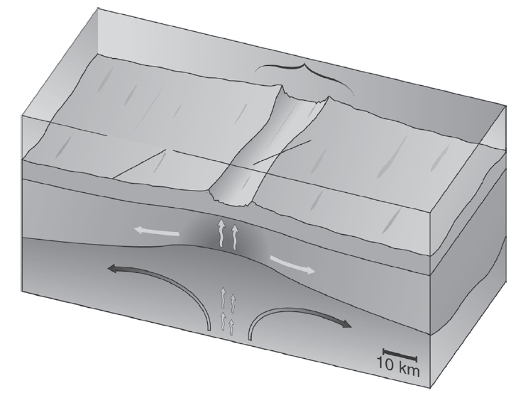According to the theory of plate tectonics, the Earth’s crust is broken into many slowly moving plates. *Sea floor spreading* occurs at the mid-ocean ridge where two plates are moving away from each other. Here, magma rises up from below as the sea floor spreads out to either side as shown in Figure 1. This spreading occurs at about the same rate as your fingernails grow.

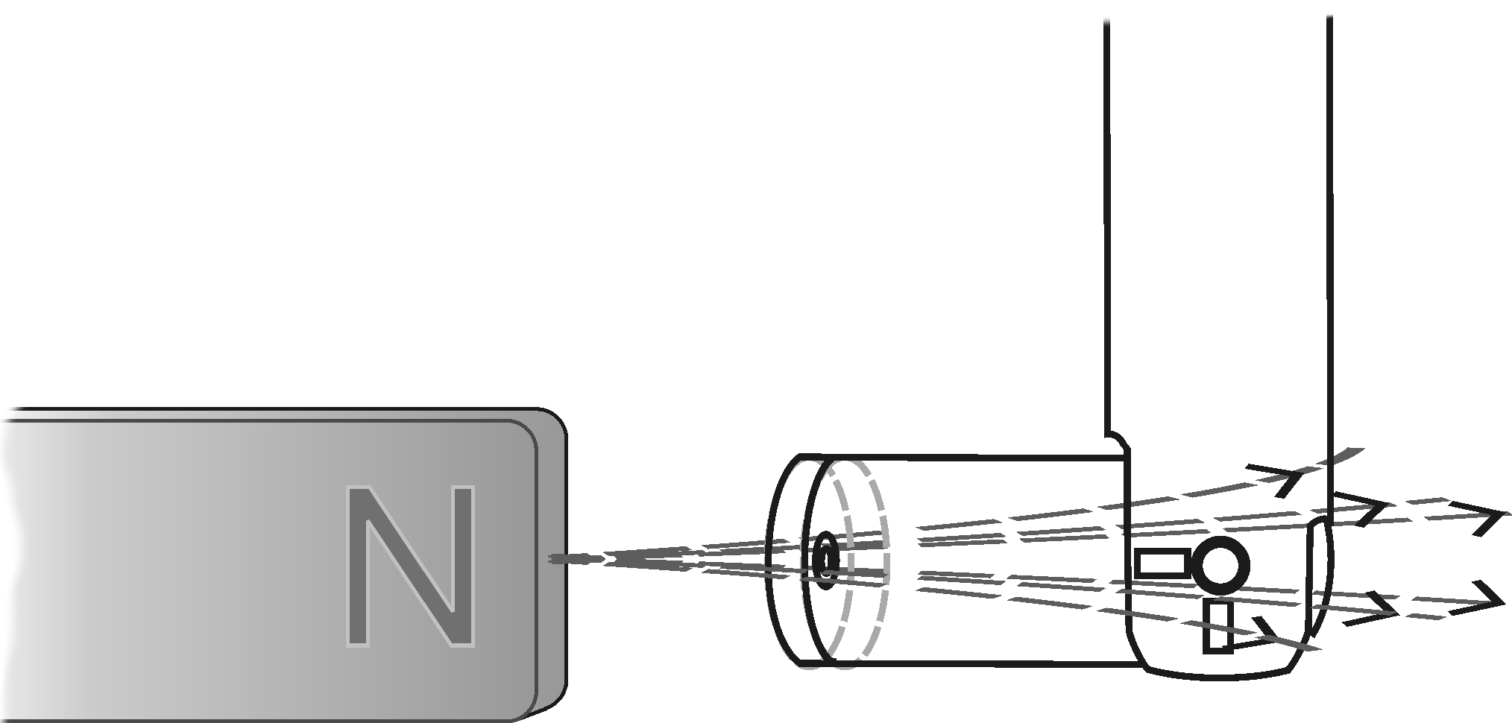

*Magnetic field lines through the sensor*

At the mid-ocean ridge, magma rises up from the mantle below and cools. As it continues to cool, iron in the rock aligns itself with the magnetic field of the Earth, much like the needle in a compass. When the rock solidifies, this magnetic “signature” is locked in place.

Throughout history, the orientation of the Earth’s magnetic field has varied greatly. At times, the magnetic pole in the north has reversed completely and was located near the south geographic pole. On average, the Earth’s magnetic field reverses every several hundred thousand years with the most recent reversal occurring about 780,000 years ago.

In this experiment, you will use a model of a sea floor spreading zone. The mid-ocean ridge is running north to south down the center of the model. You will use a Magnetic Field Sensor to map the magnetic field of your model and use it to explain how this is evidence of sea floor spreading.

**Pre-Lab: Investigating Magnetism**

Materials

|  |  |
| --- | --- |
| LabQuest | tape |
| LabQuest App | scissors |
| Vernier Magnetic Field Sensor | paper clips |
| unmarked bar magnet or cow magnet | small stickers (*optional*) |
|  |  |

Pre-Lab Questions

1. What happens when you bring a magnet close to some paper clips? Does it matter which end of the magnet is brought near them?

2. What happens when you bring two magnets close to one another? What happens if you turn one of the magnets around?

Part I Investigating Bar Magnets

1. Set the switch on the Magnetic Field Sensor to 6.4 mT (low amplification). Connect the Magnetic Field Sensor to LabQuest and choose New from the File menu..
2. 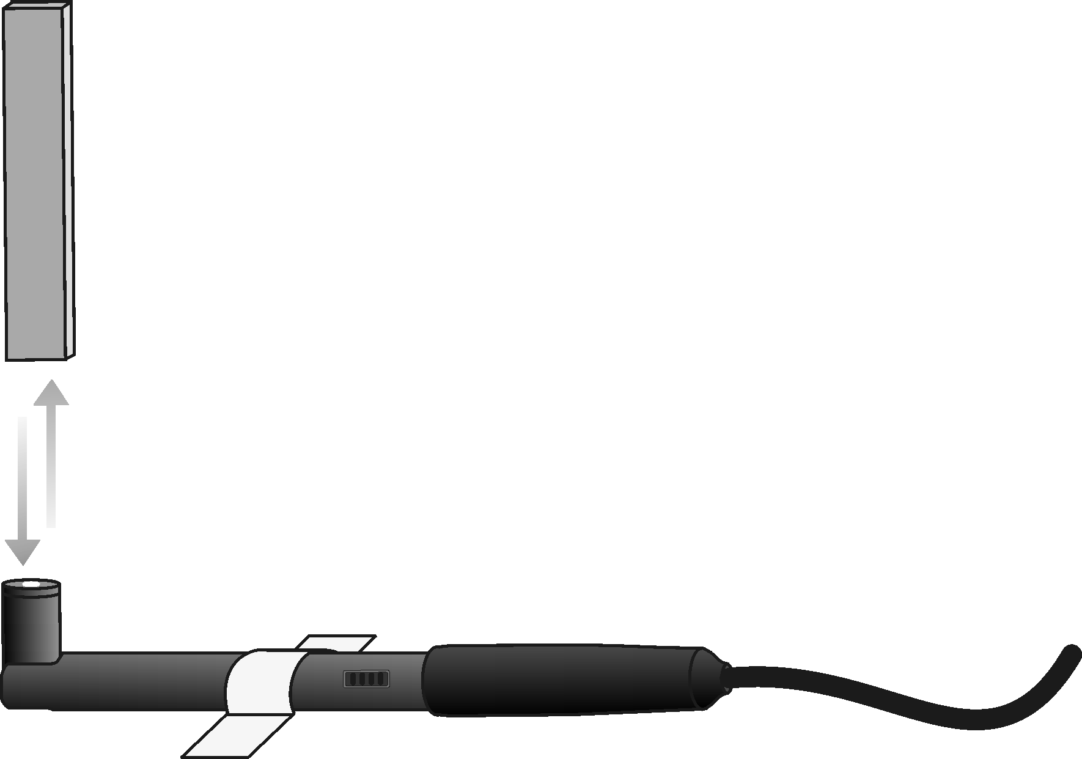Tape the Magnetic Field Sensor to the table with the white dot facing up (see Figure 1).
3. On the Meter screen, tap Rate. Change the data-collection rate to 2 samples/second and the data-collection length to 10 seconds.
4. Zero the Magnetic Field Sensor. This reduces the effect of the surrounding environment on the magnetic field reading.

*Figure 1*

* 1. Move all magnets far away from the Magnetic Field Sensor.
  2. When the readings on the screen stabilize, choose Zero from the Sensors menu. When the process is complete, the readings for the sensor should be close to zero.

1. Hold the magnet vertically about 20 cm above the Magnetic Field Sensor. One end of the magnet should be lined up with the white dot on the sensor as shown in Figure 1.
2. Start data collection. Slowly move the magnet toward the Magnetic Field Sensor and then away. You have 10 seconds to complete this motion. Keep track of which end of the magnet you have tested.
3. Sketch and label the resulting graph on the blank graph titled Trial 1 in the Data section.
4. Turn the magnet around so that the other end is facing the white dot on the Magnetic Field Sensor.
5. Repeat Steps 6 and 7 but sketch your results in the graph titled Trial 2 in the Data section.
6. Place a sticker (or small piece of tape) on the end of the magnet that produced a positive reading with the Magnetic Field Sensor.
7. Remove the tape from the Magnetic Field Sensor and turn it over so that the white dot faces down. Tape the sensor to the table.
8. Zero the Magnetic Field Sensor in the new position.
   1. Tap Meter.
   2. Move all magnets far away from the Magnetic Field Sensor.
   3. When the readings on the screen stabilize, choose Zero from the Sensors menu. When the process is complete, the readings for the sensor should be close to zero.
9. Hold the magnet with the sticker pointing down toward the Magnetic Field Sensor.
10. Start data collection. Slowly move the magnet toward the Magnetic Field Sensor and then away. You have 10 seconds to complete this motion.
11. Sketch and label the resulting graph on the graph titled Trial 3 in the Data section.

Data:

Part I

Trial 1

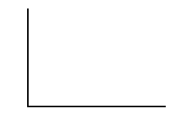

Trial 2



Trial 3



1. What happens when you bring two like poles together? What happens when you bring two unlike poles together?
2. How is it possible that the same end of the magnet can produce both a positive and a negative magnetic field reading?
3. Where was the Magnetic Field Sensor when it produced the greatest magnetic field intensity?
4. It is often said that the Earth behaves magnetically like a giant magnet. How could you use a Magnetic Field Sensor to determine which direction is North?

**SCIENCE CONCEPTS**

____________________________________________________________________________

____________________________________________________________________________

____________________________________________________________________________

____________________________________________________________________________

____________________________________________________________________________

**Investigative question**

If we create a map of the magnetic field intensities of a spreading ridge, will the patterns on both sides of the ridge be similar or different?

**OBJECTIVE**

____________________________________________________________________________

____________________________________________________________________________

**VARIABLES**

Manipulated Variable (Independent):______________________________________________

Responding (Dependent):________________________________________________________

**HYPOTHESIS** (If…then…because)

____________________________________________________________________________

____________________________________________________________________________

____________________________________________________________________________

____________________________________________________________________________

____________________________________________________________________________

____________________________________________________________________________

____________________________________________________________________________

**DIAGRAM OF THE EXPERIMENT** (based on the procedure)

|  |
| --- |
|  |

**Lab: Sea Floor Spreading**

Materials

|  |  |
| --- | --- |
| LabQuest | model sea floor spreading zone |
| LabQuest App | ruler |
| Vernier Magnetic Field Sensor |  |

Procedure

1. Set the switch on the Magnetic Field Sensor to 6.4 mT (low amplification). Connect the Magnetic Field Sensor to LabQuest and choose New from the File menu.
2. Zero the Magnetic Field Sensor.
3. Remove anything magnetic from the area where data collection will take place. This includes moving the model sea floor spreading zone.
4. Bend the tip of the sensor so it is perpendicular to the body of the sensor. Hold the sensor parallel to the table over the area where you will be collecting data, with the white dot near the tip of the sensor facing up as it will be during data collection (see Figures 2 and 3).

Figure 2

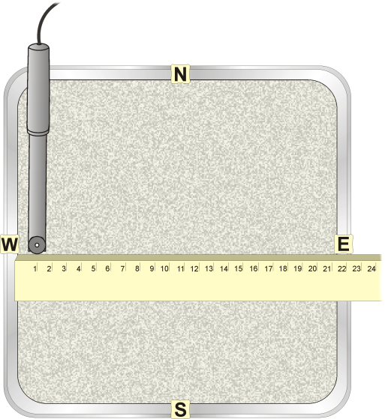

1. When the readings on the screen stabilize, choose Zero from the Sensors menu. When the process is complete, the readings for the sensor should be close to zero.
2. Prepare the model sea floor spreading zone for data collection.
3. Place the model sea floor spreading zone on your table with the side marked North at the top
4. Position the ruler so that it is lined up with the East and West marks on the sides of the pan. Align the 0 cm mark with the left edge of the pan as shown in Figure 2.
5. Start data collection and position the tip of the Magnetic Field Sensor at the 0 cm mark. **Important:** For each reading, make sure the probe is at the same height as the ruler and the white dot is facing up.
6. When the magnetic field reading displayed on the screen stabilize, record the value in your data table.
7. Move the Magnetic Field Sensor to the 1 cm mark. When the reading has stabilized, record the value in your data table.
8. Repeat the Step 6 procedure at 1 cm intervals until you reach the other side of the pan.
9. When data collection is complete, stop data collection.

Data

**TABLE__:____________________________________________________________**

|  |  |  |  |
| --- | --- | --- | --- |
| Distance from Western Edge (cm) | Magnetic Field Intnsity (mT) | Distance from Western Edge (cm) | Magnetic Field Intnsity (mT) |
|  |  |  |  |
|  |  |  |  |
|  |  |  |  |
|  |  |  |  |
|  |  |  |  |
|  |  |  |  |
|  |  |  |  |
|  |  |  |  |
|  |  |  |  |
|  |  |  |  |
|  |  |  |  |
|  |  |  |  |
|  |  |  |  |
|  |  |  |  |
|  |  |  |  |
|  |  |  |  |
|  |  |  |  |
|  |  |  |  |
|  |  |  |  |
|  |  |  |  |

Data Analysis

1. Create a graph of your data. The mid-ocean ridge runs north to south down the center of your model. Use a ruler or straightedge to draw a line on your graph representing the mid-ocean ridge. Label the line “Mid-Ocean Ridge”.
2. Draw the bands of magnetic reversal on your graph.
3. Study your graph. A change between normal magnetic field (“normal” meaning the north magnetic pole is aligned with the north geographic pole) and reverse magnetic field (“reverse” meaning the north magnetic pole is aligned with the south geographic pole) occurred each time the line crosses zero. Using a straightedge or ruler, draw a vertical line on your graph at each point where the line crosses zero.
4. In locations where the magnetic field values are positive, the magnetic field of the Earth was normal. In locations where the magnetic field values are negative, the magnetic field of the Earth was reversed. Lightly shade the bands of ocean floor where the Earth’s magnetic field was reversed with a colored pencil.
5. Across the top of your graph, label each band either “Normal” or “Reverse”.
6. Toward the bottom of your graph, draw two arrows indicating the direction of movement of the ocean floor. Remember from Figure 1 that the ocean floor is moving away from the mid-ocean ridge.
7. 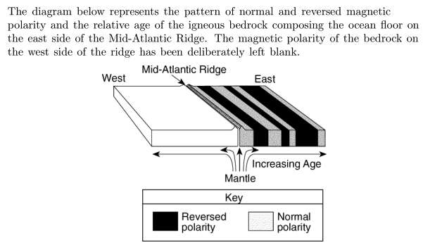

Complete the magnetic pattern of the igneous bedrock on the Western side of the mid-ocean ridge in the image above.

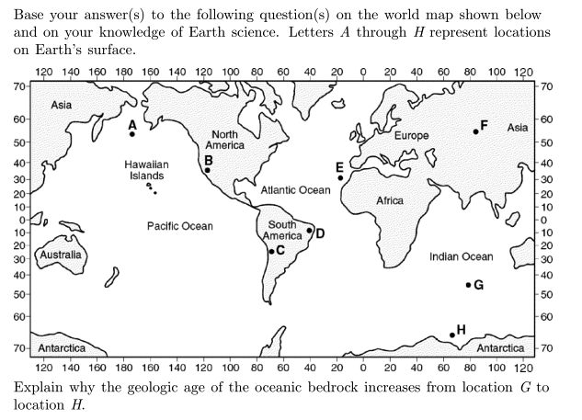

1. What is sea floor spreading?
2. Explain how the Earth’s magnetic reversals provide evidence of sea floor spreading.

**What relationships did you observe between the variables?**

______________________________________________________________________________

______________________________________________________________________________

______________________________________________________________________________

______________________________________________________________________________

______________________________________________________________________________

______________________________________________________________________________

______________________________________________________________________________

**What predictions can you make based on your observations?**

______________________________________________________________________________

______________________________________________________________________________

______________________________________________________________________________

______________________________________________________________________________

**CONCLUSION**

I accept or reject my hypothesis (circle one)

What evidence did you use to accept or reject your hypothesis?

______________________________________________________________________________

______________________________________________________________________________

______________________________________________________________________________

______________________________________________________________________________

How can you use this knowledge?

______________________________________________________________________________

______________________________________________________________________________

______________________________________________________________________________

______________________________________________________________________________

**Turn in your data table, graph, and answers to the questions above along with your lab report.**