Lab 6: Mineral Identification and Use
Section | Points
Concepts/Objective 5
Variables/Hypothesis 5
Observations/Data 5
Procedure 5
Questions/Conclusion 10
Total
Regents Minutes
Project Director
Safety Director
Materials Manager
Technical Manager
LabQuest #
Laptop #

Introduction/Pre-Lab
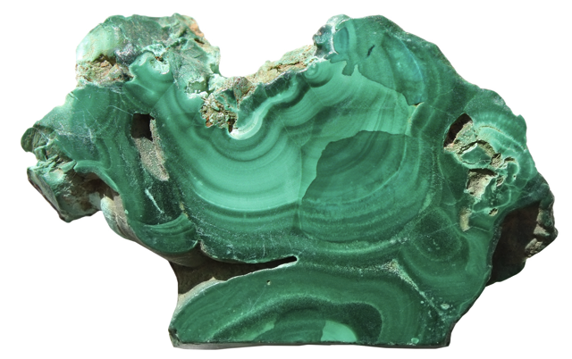
Nearly all rocks are composed of the elements, compounds, and mixtures that Earth scientists call minerals. A mineral is defined as a natural chemical solid of inorganic origin that has well-defined properties and a specific range of composition. That is, each mineral has a unique and uniform chemical makeup, which gives it uniform chemical and physical properties. We can test for these properties to identify minerals. There are thousands of minerals, but most of them are rare. The great majority of the rocks that we see are composed of only about a dozen of the most common minerals.
Some rocks contain no minerals. For example, coal is made of carbon from the accumulation of the remains of fossil plants. Because of its organic origin, coal contains no minerals. Some limestone is derived from the hard parts of shellfish and coral. This kind of limestone may therefore contain few or no minerals. On the other hand, ice is a mineral because it fits the definition above. Yet, no rocks contain ice as a mineral constituent.
Some rocks contain only a single mineral. Quartzite is composed of quartz, either pure or with minor impurities. Marble is predominantly calcite. However, most rocks contain a variety of minerals. Granite usually contains feldspar, quartz, mica, and amphibole. Other minerals, such as magnetite and pyroxene, may also be present.
Minerals are identified by their observable properties. Geologists have selected certain observations that are most useful in identifying different minerals.
Color is one of the most readily observed characteristics. Some minerals are easy to identify by their color. Almandine (a variety of garnet) is always dark red. Pyrite is a brassy yellow. However, many light-colored minerals can be discolored by small amounts of impurities. For example, quartz may be colorless (clear), white, pink, green, brown, or even black. In addition, some different minerals are the same color; for example white quartz and calcite. Therefore, although color is easy to see, it can also be misleading.
- Why is color of limited use in identifying minerals?
______________________________________________________________________________

Luster is the way that light behaves at the surface of a mineral. Geoscientists usually characterize luster as metallic (shiny with no entry of light) or nonmetallic. It is important to note that light does not penetrate the surface of a mineral that has a metallic luster. Minerals with this kind of luster have a metallic luster. Minerals with this kind of luster look like they are made of a hard metal. Transparent or translucent surfaces cannot have a metallic luster. Nonmetallic lusters include, glassy, pearly, waxy, and earthy (dull). When observing luster, ask yourself, “Does this look like it could be made from a hard metal?”
- What is the luster of aluminum foil?

______________________________________________________________________________

- What types of luster are shiny, but not metallic?

______________________________________________________________________________
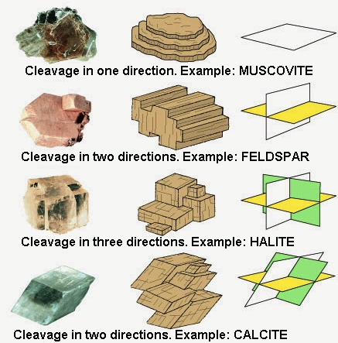
Cleavage is the way a mineral splits, generally along flat planes. Cleavage depends on the arrangement and bonding of molecules. Minerals tend to split along the planes of weak bonds between their atoms. In specifying the cleavage properties of a mineral, scientists count the number of nonparallel planes of cleavage, and the angle between those cleavage planes. For example, the mica minerals split in one direction, forming thin sheets. Halite (rock salt) crystals cleave in three directions at right angles (90°) to each other. Many minerals cleave parallel to the crystal faces. However, some, like quartz, do not split parallel to any crystal face.
Fracture is an uneven breakage. Asbestos breaks into thin fibers. Quartz fractures along curved, sea-shell like surface. This is a property known as conchoidal fracture. The fracture of garnet produces surfaces that are flat enough to look like cleavage planes, even though they are not true cleavage surfaces.
- How are cleavage and fracture different?
______________________________________________________________________________
Hardness of a mineral is determined by using it to scratch other solids. We test hardness by drawing the pointed edge of the unknown mineral across a clean surface of a known substance. A substance will scratch only materials that are either softer or have the same hardness. If the mineral does not scratch the known substance, the mineral is softer. The figure below shows Mohs’ Scale of Hardness. Hardness is determined by the strength of atomic and molecular bonding in a mineral. The diagrams in the figure illustrate the hardness of several common materials.
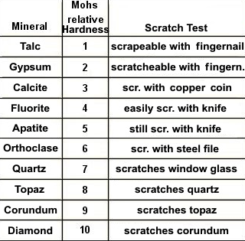
- What two minerals on the Moh’s Hardness Scale can easily be scratched by your fingenail?

_______________________________________________________________________
- How is hardness usually tested?

______________________________________________________________________________
Streak test shows the color of the powder of mineral. Streak is tested by rubbing the mineral across a white or black porcelain plate. Minerals that have a metallic luster often leave a streak that is a different color from the surface of the sample. For example, pyrite is a brassy yellow in color. However, the streak is pyrite is green to black.
Specific Gravity is the ratio of the density of a mineral to the density of water. As a ratio, specific gravity has no units. However, specific gravity is the same number as the density in grams per cubic centimeter. Many common minerals have a specific gravity (density) in the range of 2.5-3 (a density of 2.5-3 g/cm³).
There are a number of other properties that are found in only a few minerals, which can make those minerals very easy to identify.
For example:
- Double Refraction – crystal can break light into two images
- Crystal Shape – Shape assumed by a crystal during its growth. (Note: crystal shape is not maintained once the crystal is broken)
- Radioactivity – Property of minerals where particles are emitted. Can be detected with a Geiger counter.
- Reactivity to acid – minerals bubble when exposed to acid
- Magnetism – mineral is attracted to a magnet
- Taste – salty or bitter taste

SCIENCE CONCEPTS (5 points)
____________________________________________________________________________
____________________________________________________________________________
____________________________________________________________________________
____________________________________________________________________________
____________________________________________________________________________

Investigative question
If we describe the characteristics of each sample in our tray, which sample will be identified as quartz?
OBJECTIVE
____________________________________________________________________________
____________________________________________________________________________

VARIABLES (5 points)
Manipulated Variable (Independent):______________________________________________
Responding (Dependent):________________________________________________________
HYPOTHESIS (If…then…because)
____________________________________________________________________________
____________________________________________________________________________
____________________________________________________________________________
____________________________________________________________________________
____________________________________________________________________________
____________________________________________________________________________
____________________________________________________________________________

Materials

- Minerals
- Nail
- Glass Plate
- Penny
- Streak Plate
- Magnet
- Hand lens

Procedure
- Choose one sample at a time.
- Identify its luster as metallic or non-metallic
  - If your sample has metallic luster…
    - Identify the hardness of your sample using the Moh’s Hardness scale and the tools provided
    - Determine if your sample displays cleavage or fracture
    - Identify the streak color of your sample
    - Identify any other distinguishing characteristics
  - If your sample has a nonmetallic luster
    - Identify the hardness of your sample using the Moh’s Hardness scale and the tools provided
    - Determine if your sample displays cleavage or fracture
    - Identify the streak color of your sample
    - Identify any other distinguishing characteristics
- Identify the name of your mineral
- Check with your teacher to be sure you have correctly identified your samples.
DIAGRAM OF THE EXPERIMENT (based on the procedure) (5 points)

OBSERVATIONS/DATA (5 points)
TABLE__:____________________________________________________________
Sample # | Luster | Hardness | Cleavage or Fracture | Other Distinguishing Characteristics | Mineral Name
DATA ANALYSIS
Refer to pages 2 and 3 in the ESRT, the mineral resources map of New York, and the mineral Id books to answer the following questions.
- Choose 3 mineral resources on the attached map and identify the following.
- Landscape region they are found in.
- Type of rock they are found in.
- Age of the rock they are found in
- Uses for the resources
Resource | Landscape Region | Rock Type | Rock Ages | Uses

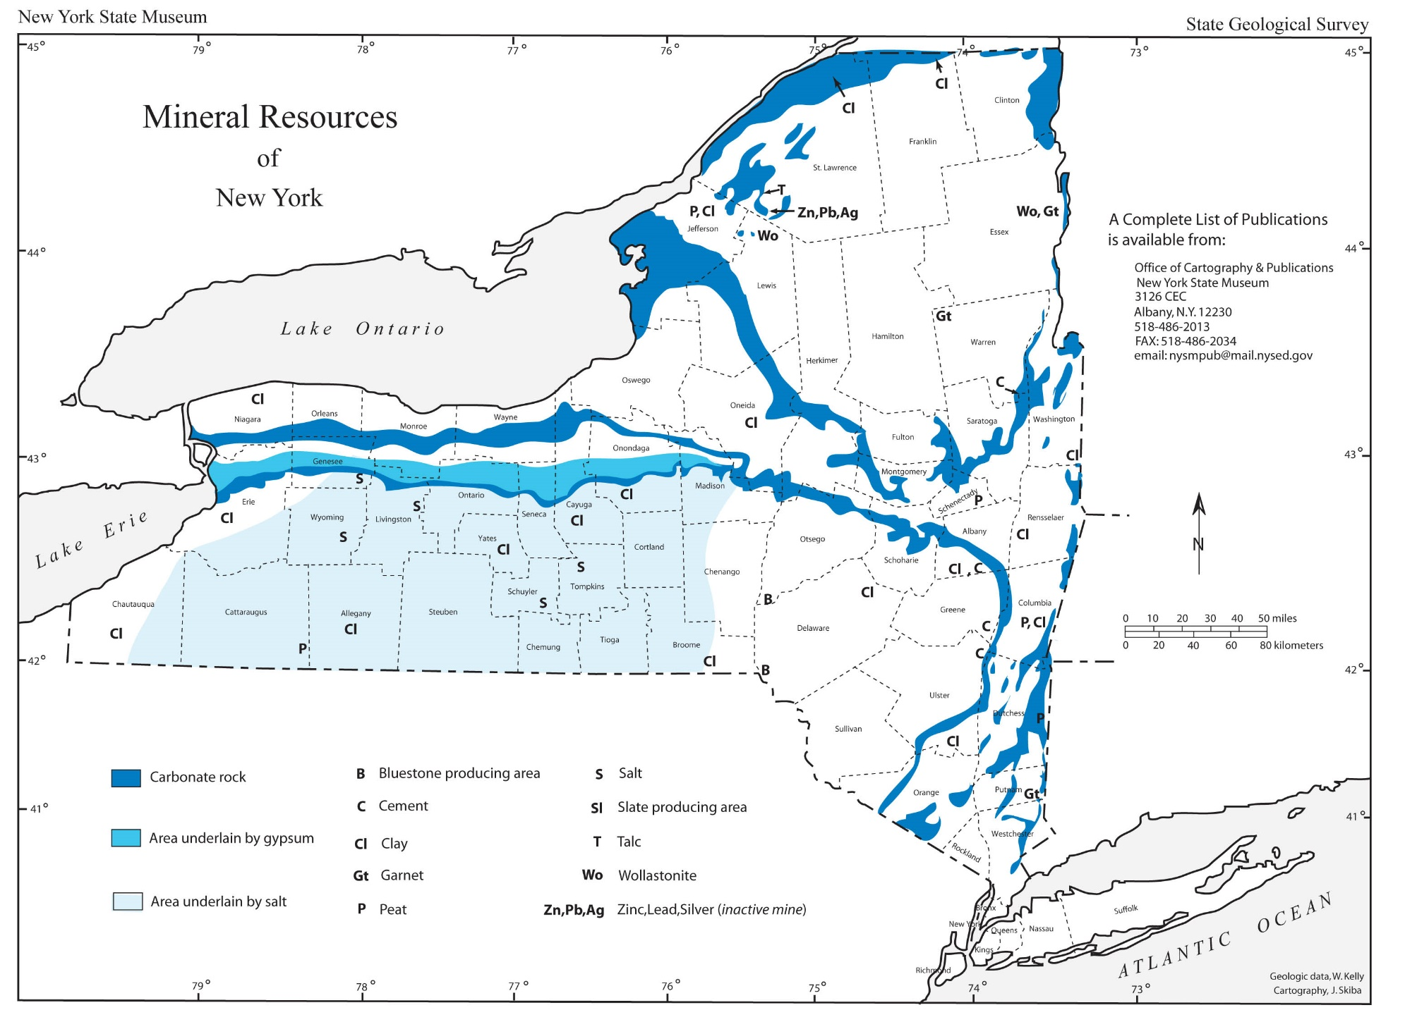

QUESTIONS (10 points)
- What property of magnetite is unusual but easily tested?

- What property makes halite easy to identify?

- For what groups of minerals is the streak especially useful?

- Diamonds are quite brittle. That is, they are easily shattered. However, what kind of damage to a diamond is unlikely to occur because of its hardness?

- Name three minerals that you likely come into contact with every day.

- Quartz is often used for jewelry and decoration, to make glass, and as the precision timekeeper in watches and clocks. Name two properties of quartz that you observed. For each property, name a different possible use for quartz based on that property.

What relationships did you observe between the variables?
______________________________________________________________________________
______________________________________________________________________________
______________________________________________________________________________
______________________________________________________________________________
______________________________________________________________________________
______________________________________________________________________________
______________________________________________________________________________
What predictions can you make based on your observations?
______________________________________________________________________________
______________________________________________________________________________
______________________________________________________________________________
______________________________________________________________________________
CONCLUSION
I accept or reject my hypothesis (circle one)
What evidence did you use to accept or reject your hypothesis?
______________________________________________________________________________
______________________________________________________________________________
______________________________________________________________________________
______________________________________________________________________________
How can you use this knowledge?
______________________________________________________________________________
______________________________________________________________________________
______________________________________________________________________________
______________________________________________________________________________
Turn in your data table, graph, and answers to the questions above along with your lab report.

