Name: __________________________ Math 7
Chapter 4 – Expressions & Equations Notes #11

Pre-Lesson Important Algebraic Vocab
Important Vocabulary for Simplifying Expressions:
  - Variable - a symbol that represents an _______ value.
  - Coefficient – the number that is placed in ______ of the variable.
  - Constant – a ______ quantity that does _____ _______.
Complete the table listing all coefficients, constants and variables.

Expression | Coefficients | Constants | Variables
8y + 1
9x + 2y + 8
-3y + 2 + 20z + 4y
14 + 3xy + 2xz – 3

Combining Like Terms
How are each set of algebraic monomial terms the same?
a) 3x 9x -5x each term has _________
b) 9y y 34y -3y each term has _________
c) -3rt 4rt 25rt rt each term has _________

LIKE Terms
have _________ variable parts
Examples:
_____ and _____
_____ and _____
_____ and _____
_____ and _____
UNLIKE Terms
have _________ variable parts
Examples:
_____ and _____
_____ and _____
_____ and _____
_____ and _____

Place the like terms in the same circle.
5 -xyz y 2 3x 4 3xyz
-3 4xyz 6y 7x 3xyz x 17

8y
xyz
4x
-9

Your Turn
Label as LIKE or UNLIKE terms:

- 6x and 6y _________
- 6m and 2m _________
- 2j and -5j _________
- -5n and -5m _________
- 5m and 7 _________
- x and 7x _________
- 4m and 4m² _________
- 6 and -4 _________

Combining LIKE Terms
Combining like terms allows us to _________ algebraic expressions.
_________ terms _________ be combined
_________ terms _________ be combined
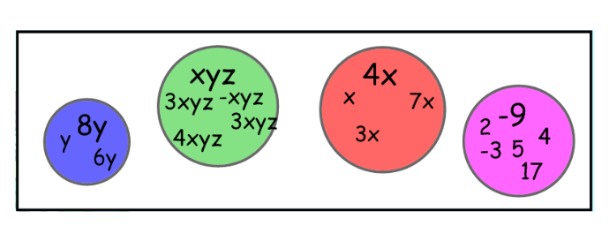
Let’s return to the diagram we used earlier and COMBINE the LIKE TERMS.

STEPS: To Combine Like Terms
- _________ like terms
- _________ them
  - _________ the _______________
  - _________ the _________ the same

Examples: Let’s simplify the following by combining like terms.
One KEY to this is to remember to always look at the sign in front of each term! It will tell you if the term you are combining is positive or negative! We will talk about this as we look at these examples.

- 3a + 2a

- 2n + 5n

- x + 4x + 5

- 7y - 2y + 6z
- -12w + 8 + 10w - 3
- 8y – 5y + 3x – 7x
- -7p - 6p

- 4x + 4 - 9x + 3

- -12a + 2b + 4b + 10a

- 9x + 2xy - x + 4xy + 3

- 5r – 8t + 3r – 4t
- -20d – 10 + 10d + 10

Your Turn – Check for Understanding
1) Place all like terms in the correct circle.
-15 20y 3x 0 7y -5x -3y -12 x y
-2x
9
3y

State whether the term is positive or negative.
2) - 5x ___________
3) + 10y ___________
4) - 10p ___________
*5) - (-3w) ___________
Simplify the expression by combining like terms.

- 20y + 2y

- 3x + 10x + 8y + 4y

- 4u + 10 - 2u - 3

- -12w + 10 + 10w – 5
- -4y – 6y + 3

