Name _____________________ Math 7
Chapter 4 – Expressions & Equations Notes #13

The Distributive Property

What is the Distributive Property?
First, what does distribute mean? “distribute” means to "______ something ______" or "______ something _____", so what does that have to do with math?
Let’s see what Tim and Moby have to say.
What does it look like?

PEMDAS
4(3 + 6)
______
______
DISTRIBUTIVE PROPERTY
4(3 + 6)
_________
_________
_________

When would we use it?
To help with _______ _______
PEMDAS
6(57)
6(50 + 7)
6(50) + 6(7)
300 + 42
342

When you have a _______in your _______

PEMDAS
2(x + 7)
____________

DISTRIBUTIVE PROPERTY
2(x + 7)
__________
__________

Why would we use it? We use the distributive property in algebra to ____________ and ____________ long algebraic terms or equations.
Steps:
- ____________ - pass out - the ____________ term with ____________ term ____________ the ____________.
- IMPORTANT: Make sure you are paying attention to the ____________ that is ____________ of the term. We will discuss a short-cut today.

Examples:
Let's simplify these expressions by using the distributive property.
IMPORTANT: Make sure you are paying attention to the sign that is in front of the term.

- 4(x + 2)

- 3(y – 3)
- 9(2x + 4)

- 2($\frac{1}{2}$ + p)
- 6(5 – 2x)
- (w + 4)10

- $\frac{3}{4}$ (4a – 20)

- 9(a + b – 2)

- (a + 3.5)10

- $\frac{10}{3}$($\frac{1}{ 10}$ a +$\frac{ 3}{20}$)

- -3(-2s + 3t)

- $\frac{ 2}{3}$ (4w - 3)

You try these:
- 3(a + 2b - 5)
- $\frac{2}{3}(\frac{1}{3}x+\frac{2}{5})$
- -9(-2x - 3)

- (4r - 3)8
- $\frac{1}{3}(4x+2)$

Name _____________________ Math 7
Chapter 4 – Expressions & Equations Notes #13.5
More with the Distributive Property!!!
Let’s do a challenge! Let’s now work BACKWARDS!
For 1-4, factor each of the following terms. To factor, you must work backwards and DIVIDE a factor by each term to “pull it out.” Let’s try some examples!
EXAMPLE: 4y + 8 = 4(y + 2)
1) 2x + 8 = ____________ **5) Which of the following is
equivalent to $\frac{3}{2}s-6$ ?
2) 10y + 16 = ____________ A) $\frac{1}{2}(\frac{2}{3}s-1)$
B) $3(\frac{1}{2}s+2)$
3) 20a - 25 = ____________ C) $\frac{1}{2}(2s-4)$
D) $3(\frac{1}{2}s-2)$
4) 6b - 3 = ____________

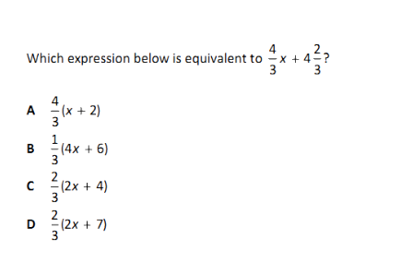
YOU TRY – COMMON CORE SAMPLE QUESTION:

6)

