Name: __________________ Math 7
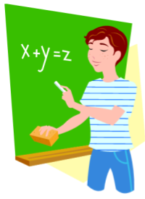
Chapter 4 – Expressions and Equations Notes #7
Two-Step Equations

Remember:
- In order to solve an equation, we need to ISOLATE the variable, or in other words, get the variable ALONE.
- We do this by looking at the operation next to the variable, and doing the OPPOSITE, or INVERSE operation!
So…
When solving two-step equations, we perform the Order of Operations – PEMDAS - in __________.

- __________, undo _______________ and _______________

- __________, undo _______________ and _______________

Examples:

1) 2y + 3 = 9 Check: ___________ the original equation.

________ the value for the variable.

___________ each side.

Both sides should be ___________.
2) 3y - 4 = 14 Check: Write the original equation.

Plug-in the value for the variable.

Evaluate each side.

Both sides should be equal.

3) $\frac{n}{8}-2=7$ Check:

4) 20 = 5w + 5 Check:

5) $8=\frac{x}{5}-4$ 6) $\frac{p}{2}+3=9$

You Try!

7) 3x – 8 = 13 Check: 8) $14=\frac{r}{2}+10$

