Name: ___________________________ Math 7
Chapter 4 – Expressions and Equations Notes #8

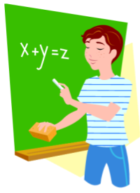
Two-Step Equations…with Integers

We know that…
- In order to solve an equation, we need to ISOLATE the variable, or in other words, get the variable ALONE.
- We do this by looking at the operation next to the variable, and doing the OPPOSITE, or INVERSE operation!
We also know that…
- When solving two-step equations, we perform the Order of Operations – PEMDAS - in REVERSE.
  - FIRST, undo ADDITION and SUBTRACTION
  - SECOND, undo MULTIPLICATION and DIVISION
Today we apply our integer knowledge…
- Rules for Integers
  - Addition: _________________________
  - Subtraction: _________________________
  - Multiplication: _________________________
  - Division: _________________________
1) -2y + 8 = 12 Check: Write the original equation.

Plug-in the value for the variable.

Evaluate each side.

Both sides should be equal.
2) -20 = -3w - 5 Check: Write the original equation.

Plug-in the value for the variable.

Evaluate each side.

Both sides should be equal.

3) $\frac{n}{8}+1=-7$ Check:

4) $\frac{r}{-3}+3=-9$ 5) $-12=\frac{w}{2}-3$

You Try!

6) -6x – 5 = 13 Check: 7) $-4=\frac{r}{4}+2$

