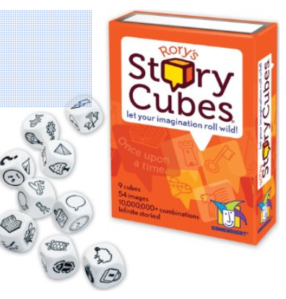
Story Cubes is a story generator. Students simply roll the cubes and use the pictures that appear on each cube serve as a path by which they are to create a story. Before rolling out the cubes the teacher or students decide upon a theme and the details student created have to relate to that theme.

