

**We Can Survive State Testing!**

**Behavior and KIA**

[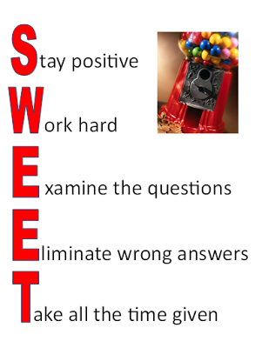](https://docs.google.com/open?id=0B4HFwfdLs3hCWUZzR3NYRi1ULWF2VVRSNGdYcHdmdw)

Check out this You Tube clip to get your kids ready for State Testing:

<http://www.youtube.com/watch?v=mIdhw1R4xys>

Get your kids ready on the day of the test:

* Stretch arms, legs, and neck
* Take deep breaths
* Visualize
* Maintain good posture

http://classroommagic.blogspot.com/2012/03/easing-test-anxiety.html

**Test Taking**

**Videos**

**[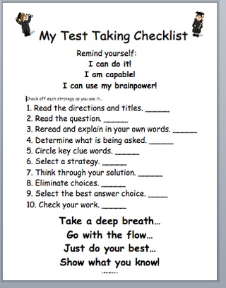](http://panickedteacher.typepad.com/blog/2010/11/panicked-teacher-loves-test-taking-strategies.html)**

Check out this series of videos on test taking strategies. They are short clips sure to get your students ready to test!

[http://www.youtube.com/view_play_list?p=D15DF1C98D5F1197&search_query=test+taking+strategies](https://webmail.gstboces.org/owa/redir.aspx?C=WlUiBEyN00uWYnZIfzOKnAvMTY139M8Izec2faFjR9zBSCuRgplB3Qcush3OhJD1IltnvWYZ0Yg.&URL=http%3a%2f%2fwww.youtube.com%2fview_play_list%3fp%3dD15DF1C98D5F1197%26search_query%3dtest%2btaking%2bstrategies)