​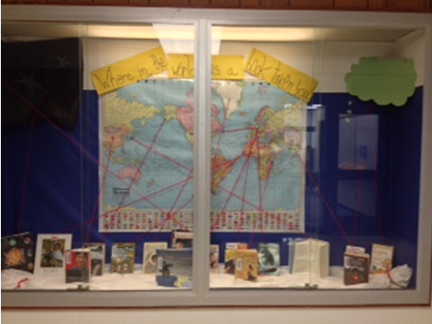​​This showcase was entitled “Where in the World has a Book Taken You.” It displayed a world may and books. Each book had a single string of yarn that was pinned to the part of the world that the book was set.

