For morning announcements I have previously presented the Treasures Words of the Week, winners for various reading or vocabulary driven contests in the building and the Habits of Mind. I am currently focusing upon providing students with reminders as to the habits of mind for each month and how they can use these habits to become the best students/people they can be.
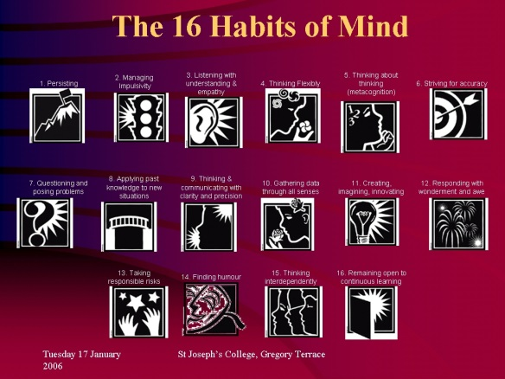

Habits of Mind – http://www.habitsofmind.org/
September - Listening with Empathy and Understanding
October – Persisting
November – Managing Impulsivity
December – Thinking Flexibly
January – Taking Responsible Risks
February – Questioning and Posing Problems
March – Applying Past Knowledge to New Situations
April – Striving for Accuracy
May – Metacognition
June - Caring

