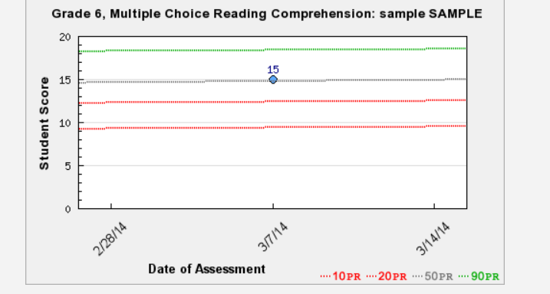

Curriculum-Based Measurement is one of the tools that I use to evaluate the current reading comprehension levels of my students. Students use the computer to read a passage and then answer 20 multiple choice questions.

