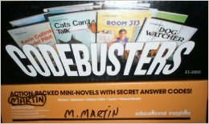

Codebusters is a reading an activity that uses mini-novels to practice reading comprehension. Students read the novels on their own and comprehension questions are written in the back of each novel. Students are provided with a plastic code breaker on which to record their multiple choice answers for the questions. Students then use the decipher page on which to place their code breaker to check for correct answers. The novelty of using the code breaker engages students and promotes accuracy in their reading and answering of questions.

