

**Classroom Environment**

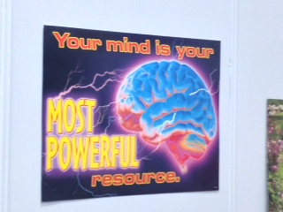

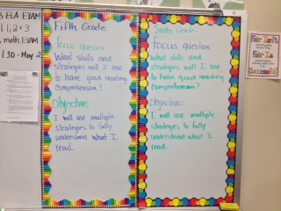

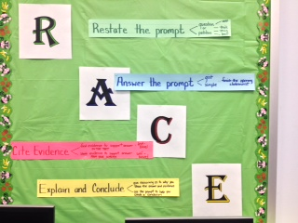

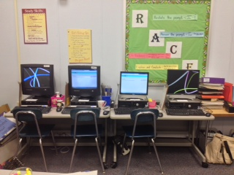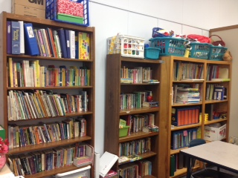

The environment of my classroom is safe, intellectually stimulating and supportive. I have used various resources to reinforce learning, positive attitude and the aim of moving forward. I have also provided a text-rich environment to promote the idea of reading, not only for classroom instruction, but on one’s own for pleasure. Students are invited to borrow from my collection of books whenever they like. The overall, “feel” of my classroom is one of safety, support and learning to which student enjoy coming.