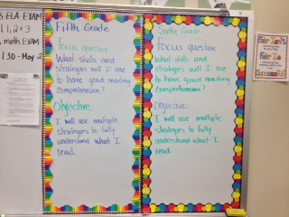

The fifth and sixth grade daily focus question and learning objective for each day is posted on the front board. It is also reviewed orally before our session begins and ends.