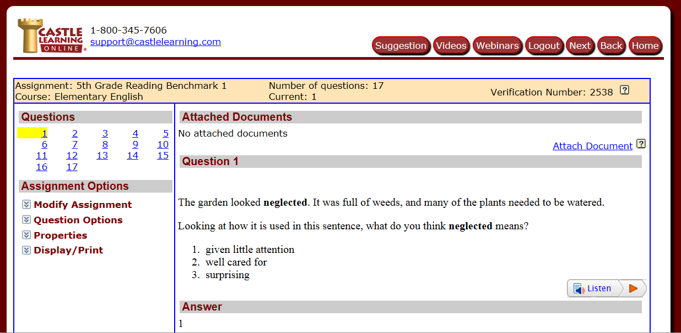

The ELA benchmark for fifth and sixth grade is taken using Castle Learning. The benchmark results gives me an ideas as how students are performing on an individual basis and how they compare to students in the same grade and the same age. These results help drive instruction.