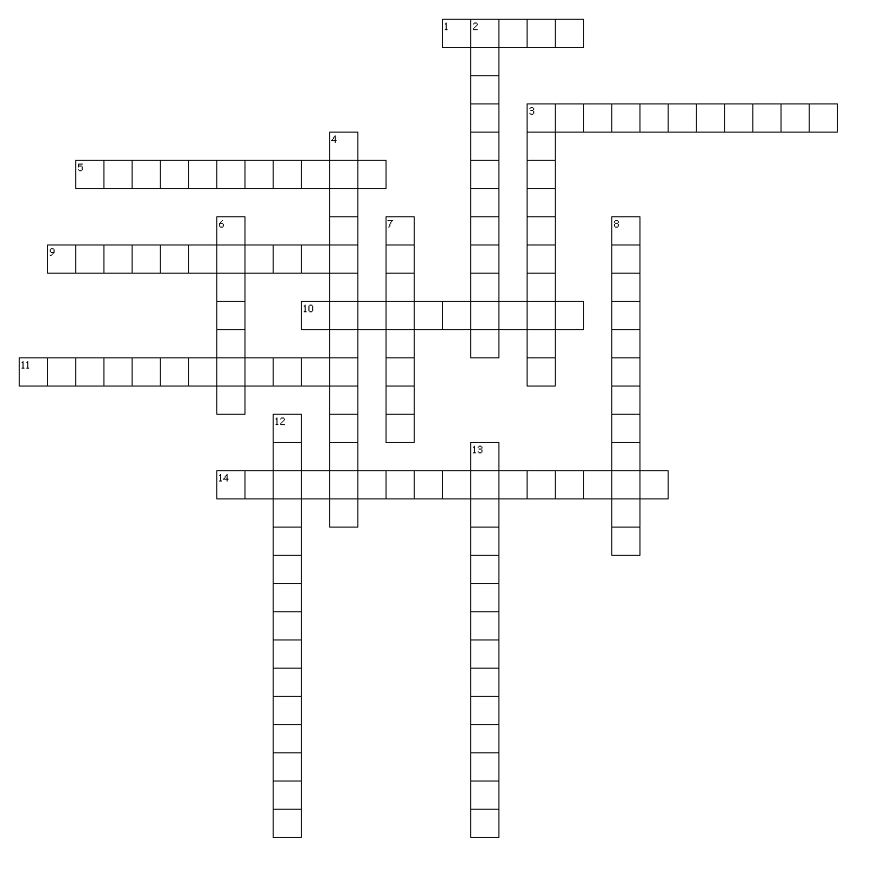
Across
Unit 7
World War Two
Adolf Hitler
Benito Mussolini
Dictator
Nazis
Fascism
Joseph Stalin
Neutrality Acts
Appeasement
Lend Lease Act
Blitzkrieg
Allied Powers
Axis Powers
Winston Churchill
Pearl Harbor
Tuskegee Airmen
1. Hitler's political party known for their racist beliefs.
3. Giving in to an aggressive country in the hope of avoiding war.
5. Dictator of Germany from 1933-1945.
9. Location of the Japanese sneak attack on the American Navy.
10. German word for lightning war.
11. Law allowing America to lease weapons to Great Britain and the Soviet Union.
14. Leader of Great Britain during World War II.

Down
2. Name given to the countries fighting against Germany, Italy and Japan.
3. Name given to the alliance of Germany, Italy and Japan.
4. Laws prohibiting the sale of weapons to nations currently at war.
6. A government ruled by a dictator who controls the lives of the people and doesn't allow anyone to
disagree with him.
7. When a leader has all the power in a country.
8. Dictator of the Soviet Union from 1922-1953.
Unit 7
#3
12. Dictator of Italy from 1922-1943.
13. Squadron of successful African American pilots during World War II.

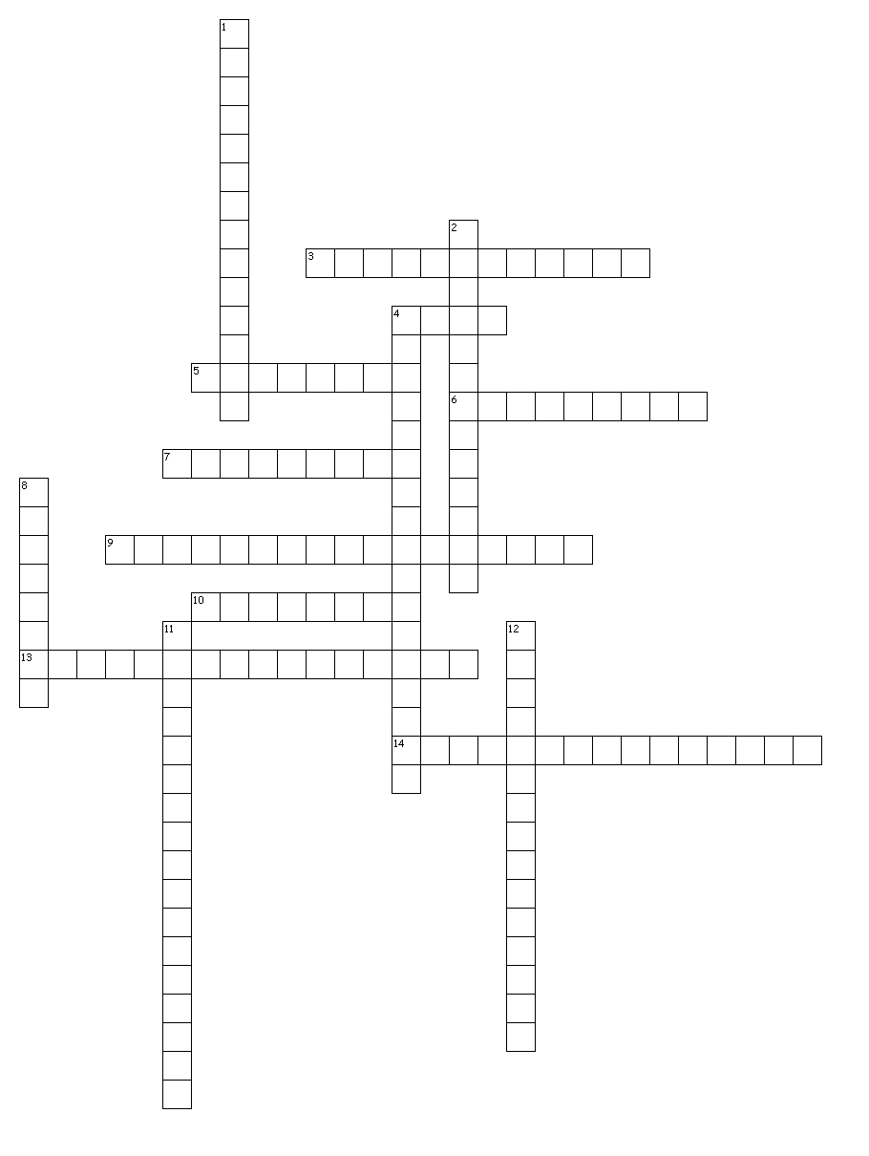

Navajo Code Talkers
Internment Camps
Genocide
Holocaust
Concentration Camp
Dwight D. Eisenhower
D Day
Harry S. Truman
Douglas MacArthur
Battle of Midway
Island Hopping
Kamikaze
Hiroshima
Nagasaki
Emperor Hirohito

Across
3. Took over as President after FDR dies in 1945.
4. Name given to the massive invasion of France in June of 1944.
5. 2nd Japanese city to have a bomb dropped on it.
6. 1st Japanese city to have an atomic bomb dropped on it.
7. The killing of the Jews and others during World War II.
9. Places Jews and others were sent to work and die by the Nazis during World War II.
10. Japanese pilots who intentionally flew their planes into American ships.
13. Head American General in the Pacific during World War II.
14. Japanese leader during World War II.
Down
1. Turning point in the war against the Japanese when we sunk 4 of their aircraft
carriers.
2. Strategy of attacking some Japanese held islands while bypassing others.
4. Head American General in Europe during World War II.
8. The deliberate mass murder of an entire race of people.
11. Native Americans who used their language as a secret code.
12. Places Japanese Americans living on the west coast were sent during the war for
fear they were spies.

