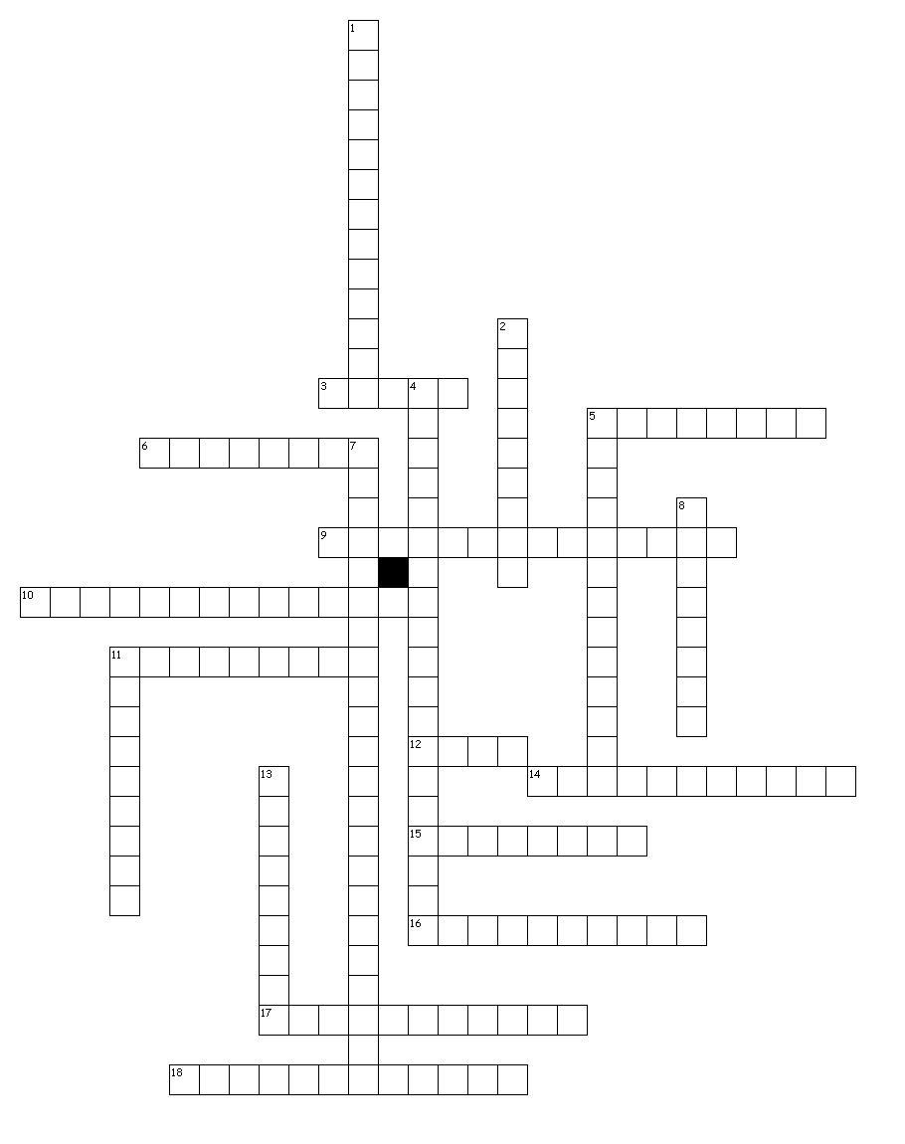
Unit 2
#6
Across
3. Pieces of a company that can be bought and sold by the public.
5. Banking monopoly owner who used his profits to buy and control other corporations.
6. Poor, run down, unsafe inner city apartments in the inner city.
9. Making large amounts of a product more quickly and cheaply.
10. Monopoly owner who dominated the steel industry.
11. Place in Chicago, started by Jane Addams, where the poor could go for food, clothing, shelter, and
educational classes.
12. Poor, run-down, urban neighborhoods.
14. Business that sells shares of stock in itself to the public.
15. People born in America who resented the new waves of immigrants entering the USA.
16. Group of employees from the same industry that worked to gain better pay and working conditions for
workers.
17. Place in New York Harbor where immigrants were processed upon entering the US.
18. Inventor responsible for the lightbulb, phonograph, power plant and 1,000 items.

Down
1. A riot that broke out during a strike in Chicago that killed four strikers, a policeman, and several
bystanders.
2. Dark, crowded, hazardous workplace in the inner city.
4. Law prohibiting Chinese workers from entering the USA for a period of ten years.
5. Monopoly owner who dominated the oil industry.
7. Fire at a New York City factory that killed over a hundred workers and led to many safety laws being passed.
8. When a single company totally dominates an industry.
11. Perfected the assembly line method for making automobiles.
13. Name given to this time period because of the unbelievable wealth of a small % of Americans while the
majority of the country was living in poverty.
Mass Production
Henry Ford
Corporation
Stock
Thomas Edison
Monopoly
JD Rockefeller
Andrew Carnegie
JP Morgan
Sweatshop
Trade Union
Triangle Shirtwaist Fire
Haymarket Riot
Chinese Exclusion Act
Ellis Island
Nativist
Tenement
Hull House
Slum
Gilded Age

