Praise: The Do’s and Don’ts

Do
*Notice students' good efforts and strategies and praise them.
*Be specific about the praised behaviors and reinforce this behavior with your feedback.
*Use praise to link the outcomes of an assignment to students' efforts.
*Talk explicitly and in detail about the strategies a student has used.
Comment on which strategies were helpful, and which were not.
*Ask a student to explain his or her work to you.

“Failure is success if we learn from it.”
~ Malcolm Forbes

“Whether you think you can or you can’t
- you are right.”
~Henry Ford
Math Mindsets:

Fostering Growth
Mindsets in Children

Don’t
*Don't offer praise for trivial accomplishments or weak efforts.
*Don't inflate praise, particularly for students with low self-esteem.
* Don't let a student feel ashamed of learning difficulties. Instead, treat each challenge as an opportunity for learning.
*Don't ever say, "You are so smart." in response to good work. Instead, praise the work a student has done
*Don't comfort students following a failure by telling them that not everyone can be good at everything.

“No matter how many mistakes you make or how slow your progress, you’re still
way ahead of everyone who isn’t trying.”

A Guide for Parents
~ Tony Robbins



GROWTH MINDSET & MATH

Growth versus Fixed Mindset
In a fixed mindset, people believe their intelligence and talents are fixed traits. They believe that talent alone creates success without effort.

In a growth mindset, people believe that they most basic abilities can be developed through dedication and hard work.

There is a growing body of evidence that students’ mindsets play a key role in their math and science achievement.
It is essential that teachers and parents strive to help children develop a growth mindset as this view creates a love of learning and resiliency. When students believe that their intelligence can increase they orient toward doing just that, displaying an emphasis on learning, effort, and persistence in the face of obstacles.

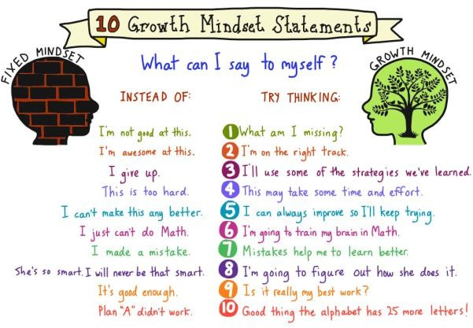
Strategies to Help your Children Develop Growth Mindset

- Pay attention and verbally praise kids for skills that don’t sound predetermined: hard work, persistence, rising to a challenge, learning from a mistake, etc., rather than
being “smart”, “brilliant” or “gifted”.
- Be a growth mindset role model. Be honest: how often do you say “I can’t
(cook/sing/balance my bank account)” or “I’m terrible at (sports/spelling/public speaking)” as if there’s no hope for you? Make sure you’re sending the right message – maybe even take on something new!
- Encourage your child to forget taking the easy route (where little learning is done) and instead embrace challenges. A sheet full of questions he already knows the answers to won’t “grow the brain” like one deeper
problem to solve (even if he doesn’t get the correct answer).
- Remember growth mindset isn’t just academic; it applies to many areas of life (athletic, musical, social). Having trouble getting the basketball into the net? Keep making mistakes on a guitar chord? Tried to initiate play with someone but it didn’t go well? Discuss the next step for improvement.
- Discourage envy of peers, and talk to your child about what he or she can learn from others who appear more successful. While skills may come more easily to some, most often there’s a (possibly unseen) element of practice, persistence, and hard work which leads to achievement.
Additional Resources

“Mathematical Mindsets” by Jo Boaler
This book provides practical strategies and activities to help teachers and parents show all children, even those who are convinced that they are bad at math, that they can enjoy and succeed in math.

https://www.classdojo.com/BigIdeas/ A full series of fun videos that explain
growth mindset in child friendly language. Includes many wonderful resources, including discussion guides for each video! We watch these in class and they are a HIT!

http://www.edutopia.org/article/growth- mindset-resources
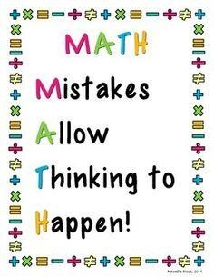
Find information about growth mindset, discover how learning mindsets can affect student performance, and explore strategies that support student confidence all on one website.

